**MILESTONE 2- STOCK MARKETING**

**NAME:** T.MANIPRIYA

**EMPLOYEE ID:** 761131

**MAIL:** [Manipriya.T@cognizant.com](mailto:Manipriya.T@cognizant.com)

**LOCATION:** Siruseri, Chennai

1. **INSERT COMPANY**

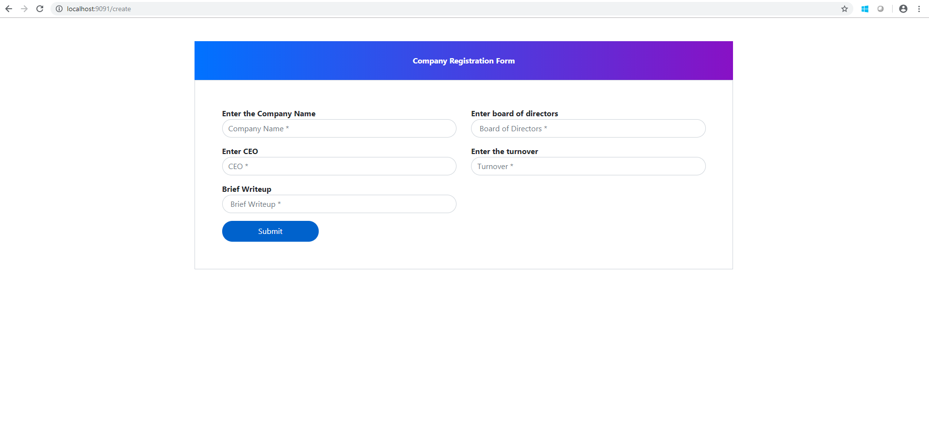**2. DISPLAY THE LIST OF COMPANIES**

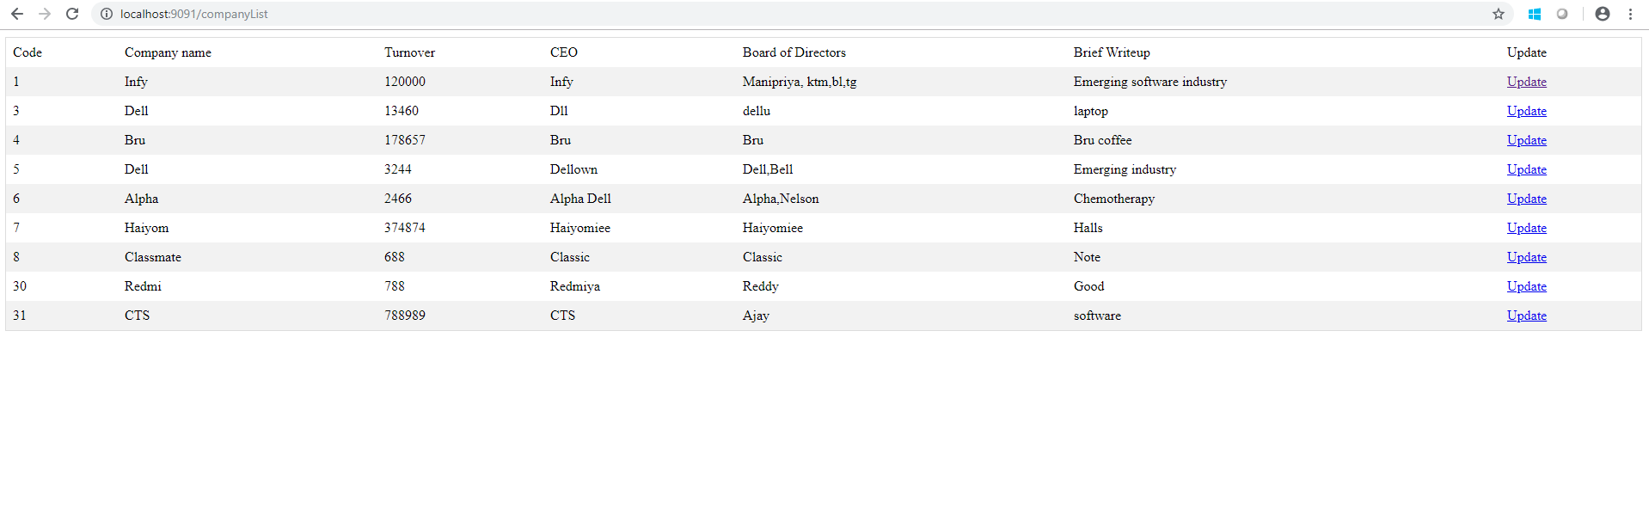

1. **INSERT STOCK**

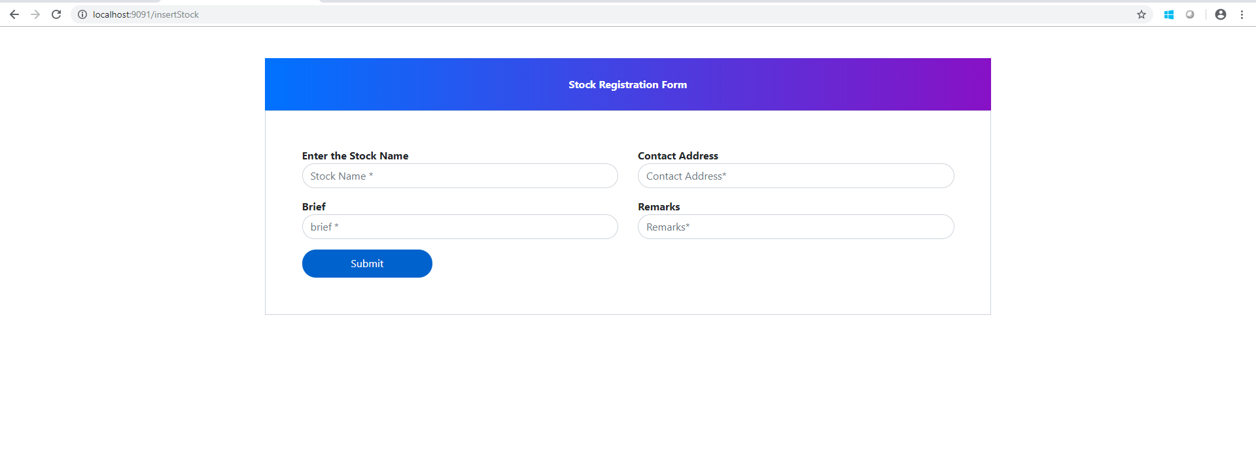

1. **DISPLAY THE LIST OF COMPANIES**

